Assignment 2 Digital and Analog Input & Output

Released Date: September 26th

Version 1.0

Format: Name the document in the combination of name、ID and No. of Assignment.

**Example: Ping Yi_30802023_Assignment2.doc**

**Email the document to “pingy@wxit.edu.cn” before Oct 1st.**

**Font’s requirement:**

**Chinese Letter “宋体五号”**

**English and digit Letter “Time New Roman 五号”**

**Task 1** Specify and mark **Arduino Uno onboard Digital and Analog Pins.**

Digital Pins : 0-13

Inport/Output

任务1 描述和标注Arduino Uno板上的数字引脚和模拟引脚。





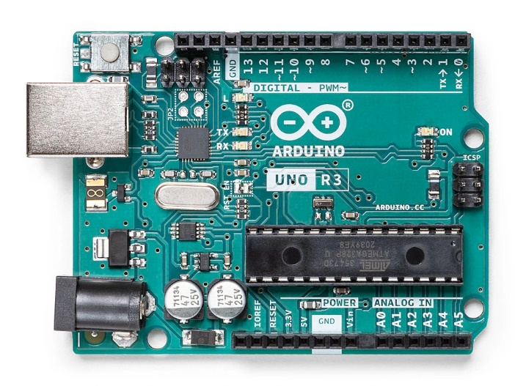

Fig 2 Arduino Uno Board

**Task 2 One** LED is linked with the **digital pin**, set up a circuit to use **a button (or two)** to control the on and off state of the LED. Draw the circuit in TinkerCAD, make the executable codes for the function.

任务2 一个LED与数字引脚相连，设置一个电路，用一个（或两个）按钮来控制LED的开启和关闭状态。在TinkerCAD中绘制电路，编写功能的可执行代码。

未按轻触按钮电路

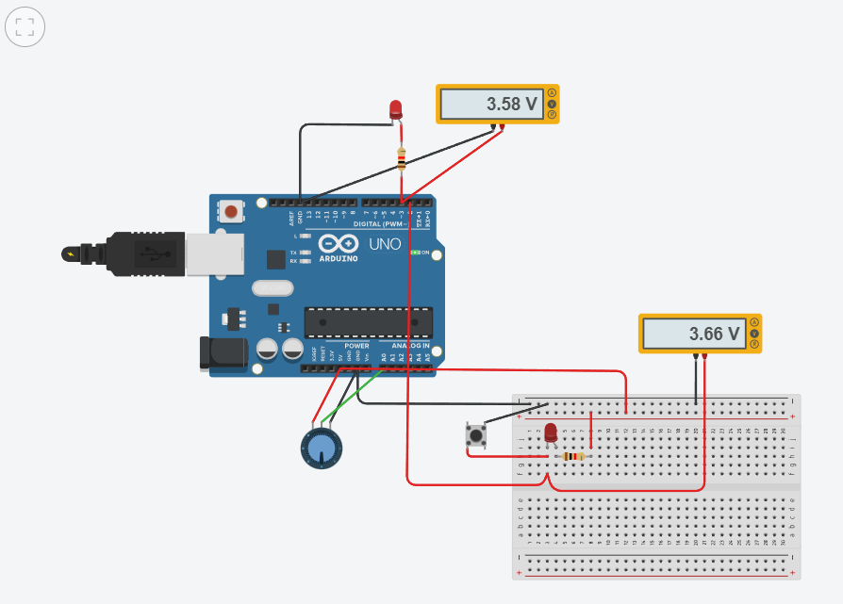

按住轻触按钮电路

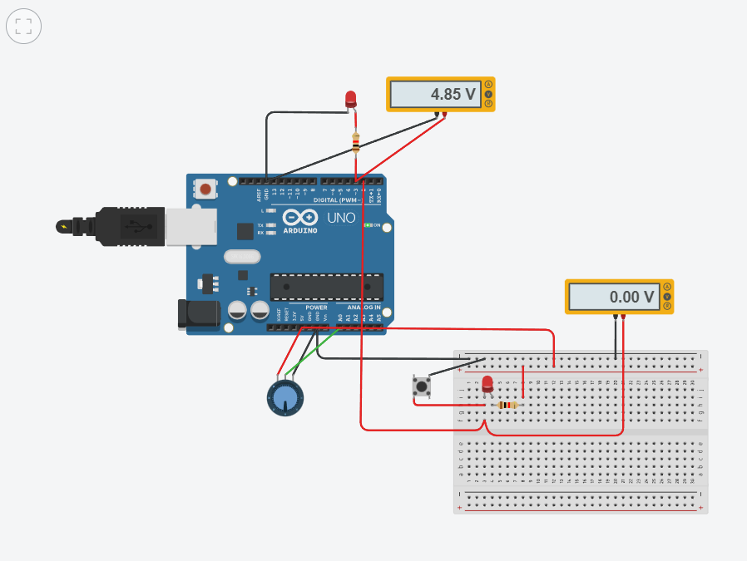

可执行代码

int sensorValue = 0;

int ledPin = 3;

void setup()

{

pinMode(A0,INPUT);

pinMode(ledPin,OUTPUT);

Serial.begin(9600);//baudrate bps bit per second

}

void loop()

{

//read the input on analog pin 0:

sensorValue = analogRead(A0);

//turn led on and wait for the time equal to potValue

digitalWrite(ledPin,HIGH);

delay(sensorValue);

//re-read the value of the pot and store it as potValue

digitalWrite(ledPin,LOW);

delay(sensorValue);

//print out the value you read:

Serial.println(sensorValue);

delay(100);//Delay a liitle bit to improve simulation performance

}

